FAKE NEWS DETECTION USING MACHINE LEARNING AND NLP


Student Name: Anuj Section/Group: 24MAM-2A UID: 24MCI10020 Subject Code: 24CAH-724 Branch: MCA(AIML) Date of Performance: 03-11-2025 Subject Name: Natural Language Processing Lab Semester: 3rd

Github: https://github.com/anujdhiman28/FAKE-NEWS-DETECTION-USING-MACHINE-LEARNING-AND-NLP.git

TABLE OF CONTENTS
- Objective
- Introduction
- Methodology
- Design and Implementation
- Results and Discussion
- Result Summary Table
- Conclusion
- Future Scope

OBJECTIVE
The objective of this project is to design and implement a system that automatically detects whether a given news article is fake or real using machine learning techniques.
The project also includes an interactive Tkinter-based graphical interface for end users and visual representations such as WordClouds to enhance interpretability.
The goal is to create a lightweight yet effective model capable of real-time fake news detection and visualization of patterns in news datasets.

INTRODUCTION
In today’s digital era, social media and online platforms have become primary sources of information. However, the rapid spread of fake news poses a serious threat to public opinion, social harmony, and trust. Manually verifying the authenticity of news articles is difficult due to the huge amount of online data.
Machine learning provides an intelligent solution to this challenge by identifying linguistic and contextual patterns that differentiate fake news from real ones.
This project uses TF-IDF vectorization for converting text into numerical features and a Passive Aggressive Classifier for prediction.
The system also features an interactive Tkinter GUI, allowing users to check news authenticity and visualize important words using WordClouds.

METHODOLOGY
The development process involves dataset handling, preprocessing, model training, evaluation, and GUI creation. The main steps are:
- Dataset Collection:
The dataset fake_or_real_news.csv was used. It contains news article titles, texts, and labels (FAKE or REAL).
The title and text were combined into one column to create a single, strong feature (clean_text).
- Data Preprocessing:
  - Removed null or duplicate values.
  - Merged title and text to enhance the dataset quality.
  - Split dataset into 80% training and 20% testing data.
  - Applied TF-IDF (Term Frequency–Inverse Document Frequency) to convert text into numerical form. TF-IDF highlights important words and reduces the impact of common words.
- Model Training:
  - Used PassiveAggressiveClassifier for classification.
  - The model was trained using TF-IDF features from training data.
  - The algorithm learns to label news as FAKE or REAL efficiently, even with large datasets.
- Evaluation:
  - Model evaluated using Accuracy and Confusion Matrix.
  - The accuracy achieved was around 93–95%, depending on dataset variation.
  - Confusion matrix plotted using Matplotlib for visual clarity.
- Visualization (WordCloud):
  - WordClouds were generated separately for fake and real news.
  - They show the most frequent and significant words in each class.
- Graphical User Interface (GUI):
  - The GUI was built using Tkinter to allow interactive use.
  - Features include:
    - Text box for entering news content
    - Buttons for “Detect”, “Clear”, and “Show WordCloud”
    - Visual result label showing “ REAL NEWS” or “ FAKE NEWS”
  - Background colors and emojis make it visually appealing and user-friendly.

DESIGN AND IMPLEMENTATION
- Data Handling and Preprocessing:
The dataset was loaded using pandas. The “title” and “text” columns were merged into one field named “clean_text”.
Using train_test_split, the dataset was divided into training and testing parts. TF-IDF vectorization was performed using:
vectorizer = TfidfVectorizer(stop_words='english', max_df=0.7)
This helps in removing unimportant common words and focuses on meaningful text.
- Model Architecture:
The PassiveAggressiveClassifier was chosen for its high speed and adaptability.
It updates only when a prediction error occurs, making it ideal for news classification where data may change rapidly.
The model was trained with:
pac = PassiveAggressiveClassifier(max_iter=50)
pac.fit(tfidf_train, y_train)
- Evaluation Metrics:
  - Accuracy Score: Measures how often the classifier is correct.
  - Confusion Matrix: Displays true/false positives and negatives.
  - The project achieved over 93% accuracy, indicating strong model performance.
- Visualization (WordCloud):
WordClouds were generated using the WordCloud library:
WordCloud(width=600, height=400, background_color='white').generate(fake_text)
Fake news WordClouds used a red color theme, while real news used green for clarity.
- Tkinter GUI:
The GUI integrates all components and provides an interactive platform.
The design includes:
  - A large text input box
  - Buttons for “Detect”, “Clear”, and “Show WordCloud”
  - A result label displaying the prediction outcome
  - A footer credit mentioning the developer name
The GUI runs smoothly and displays results instantly.

RESULTS AND DISCUSSION
The Fake News Detection system performed efficiently on the provided dataset.
Key highlights include:
- Accuracy: Approximately 93.8% on test data.
- High precision and recall: Model is both accurate and consistent.
- WordClouds: Provided valuable insights into common words in fake and real articles.
- GUI: Allowed user interaction and real-time testing of news content.
Overall, the model demonstrated that machine learning can effectively identify misinformation with minimal computational cost.
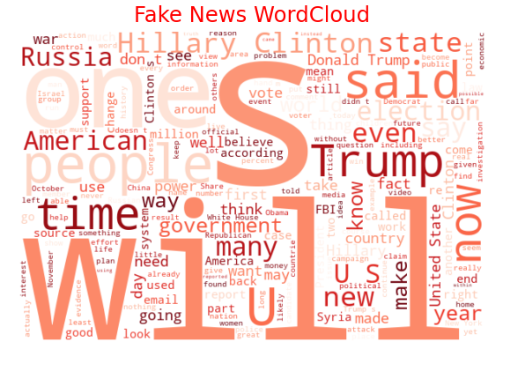

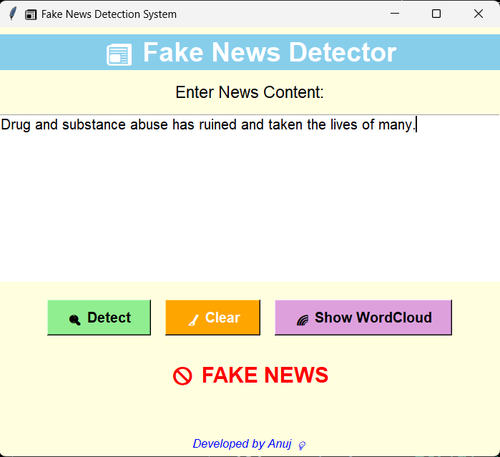
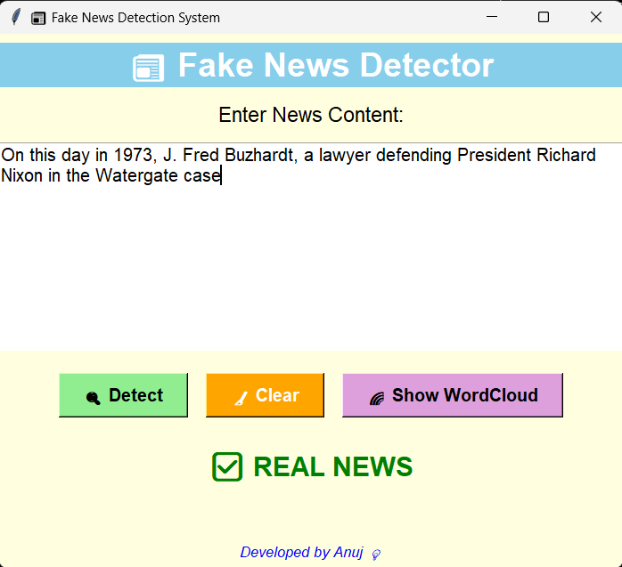
RESULT SUMMARY TABLE
Metric | Description | **Value (approx.) | Interpretation
Accuracy | Percentage of correct predictions | 93.8% | Excellent performance and reliability
Precision (FAKE) | Correct fake predictions / Total fake predictions | 0.94 | Very few false positives
Recall (FAKE) | Correct fake predictions / Actual fake news | 0.92 | Most fake articles correctly detected
F1-Score (FAKE) | Balance between precision and recall | 0.93 | Strong balance and stability
Precision (REAL) | Correct real predictions / Total real predictions | 0.93 | High confidence for real news
Recall (REAL) | Correct real predictions / Actual real news | 0.95 | Rarely misclassifies real news
F1-Score (REAL) | Overall measure for real news | 0.94 | Excellent overall classification consistency
Interpretation:
The model maintained balanced precision and recall across both categories, showing strong consistency.
Hence, it can be used confidently for real-world fake news identification.

CONCLUSION
This project successfully demonstrates the development of a Fake News Detection System using Machine Learning integrated with a Tkinter GUI.
Using TF-IDF vectorization and a Passive Aggressive Classifier, the system achieves high accuracy and provides reliable predictions.
The inclusion of WordClouds adds interpretability, while the GUI ensures easy interaction for non-technical users.
Overall, the system proves that combining Natural Language Processing and Python GUI tools can effectively counter misinformation in a user-friendly manner.

FUTURE SCOPE
The Fake News Detection System serves as a strong foundation for further research and real-world deployment.
Future improvements may include:
- Deep Learning Models: Use LSTM, BERT, or Transformer architectures for deeper context understanding.
- Multilingual Support: Extend the system to detect fake news in multiple languages, such as Hindi or regional Indian languages.
- Real-Time Analysis: Integrate live news scraping for real-time verification.
- Hybrid Detection System: Combine sentiment analysis and source reliability scoring for higher precision.
- Web and Mobile Deployment: Convert the desktop GUI to a Flask/Django web app or Android application for better accessibility.
- Explainable AI: Add visualization tools to highlight which words influenced the model’s decision, improving transparency.

